RESUME

Name: Ranjana Ratan  Profession: Classical Vocalist. (Specialization in Thumri)  Address: 201, G-Wing, Netaji Co-op. Housing Society,  9, Sion – Mahim Link road,  Mumbai- 400017.  Contact: Mobile: +91-9167419672.  +91-9821160689.  Email Id: ranjanamelodies@gmail.com  Web Site: https://www.ranjanamelodies.com/ | 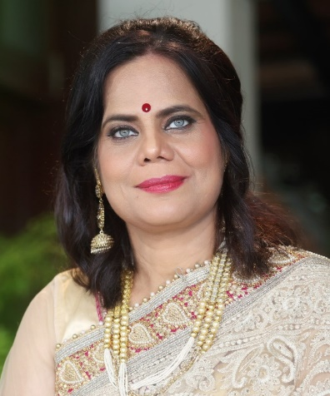

Qualification : B. Fine (Painting). M S University Baroda.
B. Mus. (Vocal). M S University Baroda.
Achievements : First Prize in Vaman Daji classical music competition,
Kankavli, Dec 2003. Awarded by Padmashree Pt. Tulsidas Borkar.
Performances :
- VASANT RAO ACHREKAR SANSKRUTIK PRATISHTHAN, Kankavali Sindhudurg, 2003.
- Independence Day Celebration, HOMI BHABHA AUDITORIUM, T.I.F.R, Colaba, Mumbai 2004.
- Koomarswamy Hall, PRINCE OF WALES MUSEUM, Mumbai, 2011.

- Thumri Concerts:
- NATIONAL GALLERY OF MODERN ART (N.G.M.A) on the occasion of Women’s Day, organized by WOMEN ART FOUNDATION, Sarangi accompanied by Ustad Anwar Hussain, Mumbai, March 2011.
- A.M.A at T.I.F.R, Mumbai, June 2011.
- Guru purnima celebration in the presence of great violinist Padmashree Pt. D.K. Datar, Jogeshwari, Mumbai, 2011.
- Urban Haat, NAVI MUMBAI ART FESTIVAL, January2013.
- OFFICERS CLUB ONGC, Baroda, July 2013.
- IIT Powai, Mumbai, September 2013.
- PANVEL CULTURAL CENTRE, Panvel, October 2014.
- AKAR POT ART, Indapur, January 2015.
- TAO ART GALLERY, Mumbai December 2015.
- ABEED HUSSAIN SANGEET MANDAL, Murud Jangira (Alibaug) January 2016.
- ABHINAV KALA SAMAJ, Indore, February 2016.
- TAJ LAND ENDS, Mumbai, May 2016 (Charity concert for Indian Cancer Society).
Other curriculum :
- A visiting faculty for Semi classical music at SNDT Women’s University. Churchgate, Mumbai.
- Trained Special children using music as a therapy.
- Cultivating various exercises in musicology, the results are satisfying and inspiring.
- Well known film director Aruna Raje recently made a documentary on Autism titled “Behind The Glass Wall” where I got a chance to view myself teaching one of my special student.
- Radio Announcer in All India Radio Mumbai since 2018.
Musical Journey:
My musical foundations were laid under the guidance of Smt. Prabhawati Verulkar at Indore. In-depth understanding of music I learned under the tutelage of Pt. Narayan Rao Patwardhan at Baroda. The interest continued and was fortunate enough to continue the Talim under Pandita Shubhada Paradkar in Mumbai.
The passion in music brought me to Gaan Saraswati Smt. Kishori Amonkar. She guided me to feel and sense the soulful realm of music.
After learning Khayal gayaki for a long time the zeal for music made me pursue various other forms of music. This led me to learn semi classical music such as Thumri, Dadra, Kajari, Chaity, Hori and Maand from Thumri maestro Begam Afroz Bano.

Since then, I found solace in this form and continue to intensely explore this form to it’s vary depth.
……RRRRR……

